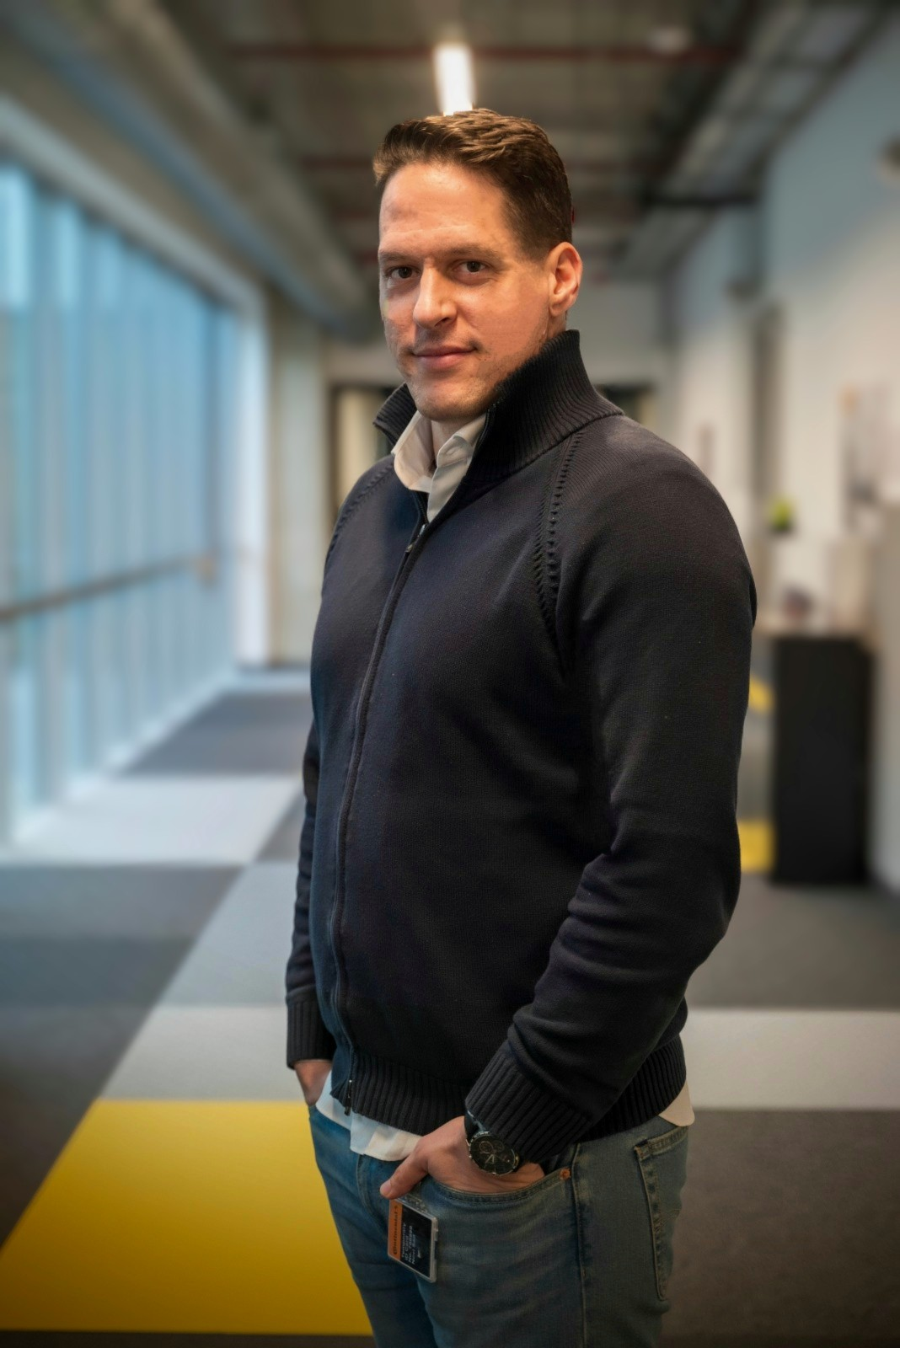**Ivan Ivani, PhD**

Address: Radnicka 16, 21000 Novi Sad, Serbia

Mobile: +381642362210

E-mail: [jasamivanivani@gmail.com](mailto:jasamivanivani@gmail.com)

LinkedIn: linkedin.com/in/iivani

Date of birth: 6th February 1986

I am a Data Scientist with a scientific background in bioinformatics and over five years of experience in data analytics within an international organization across various contexts. I have managed small data teams and implemented complex projects. I am keen to bring my international experience, problem-solving mindset, and enthusiasm to a new and challenging environment, particularly focusing on financial consulting and treasury management.

|  |  |
| --- | --- |
| **PROFESSIONAL EXPERIENCE** | |
|  |  |
| **Data Analyst** | **Oct 2023 – Present** |
| **User Experience R&D – Continental – Serbia** | |
|  | |
| * Established and maintained an efficient data management system for optical experiments and production data, supporting R&D teams globally. * Specialized in preparing graphs and processing diverse datasets from optical experiments and production End-of-Line (EOL) plants. * Created interactive dashboards using Python and PowerBI to facilitate seamless collaboration and informed decision-making. * Contributed to the team’s expansion and development of Data Science infrastructure and streamlined data processes. | |
| **Data Analytics and Management Lead** | **Jan 2021 – Jun 2023** |
| **Protection Unit – ICRC – Jerusalem and Caracas** | |
|  | |
| * Handled highly sensitive personal data, ensuring secure and ethical management. * Prepared intricate reports and infographics for strategic decision-making. * Led small teams, fostering collaboration and efficient data handling, and trained colleagues in complex SQL and Python data processes. * Acted as a Project Manager for the Jerusalem Delegation, steering the Family Visit Program through feasibility and planning phases. | |
| **Data Analyst** | **Jul 2018 – Dec 2020** |
| **Protection Unit – ICRC – Belgrade, Geneva and Damascus** |  |
| * Created an automated dashboard for the Syrian delegation that integrates external information sources into the ICRC PCP framework, mapping events and providing statistical feedback. * Developed a dashboard at HQ visualizing ETD request flows over time and country, aiding in strategic planning. * Supported delegates and operations with reports and analyses, enhancing data-driven decision-making. * Evaluated and improved the quality of Prot6 databases and infrastructure. | |
| **Research Scientist** | **Jan 2010 – Jun 2017** |
| **Institute for Research in Biomedicine - IRB Barcelona, Spain** | |
|  | |
| * Conducted molecular dynamics simulations of DNA and protein molecules, optimizing software tools like AMBER and Gromacs. * Applied advanced statistical methods to interpret biological data from experiments and simulations. * Set up a NoSQL database for storing MD simulations and contributed to disseminating research findings through graphical visualizations and scientific publications. * My most notable work in Nature Methods: Ivan Ivani et al. Nature methods 13, no. 1 (2016): 55-58. * List of all my publications: <https://scholar.google.com/citations?user=GqCZ-0QAAAAJ&hl=en> | |
|  | |
| **Intern Scientist** | **May 2015 – Aug 2015** |
| **Stanford University and Pfizer, USA** | |
|  | |
| * I spent time as a visiting researcher in the group of Eric Kool, working on a project of software optimization Worked on software optimization for computational biology simulations in collaboration with the pharma industry. * Conducted experiments on short DNA sequences and parameterized molecular dynamics software based on experimental findings. | |
| **EDUCATION** | |
|  | |
| **PhD in Bioinformatics (cum laude)** | **Dec 2016** |
| * *Universitat de Barcelona, Spain* | |
|  | |
| **MSc in Biophysics (Top 2% of the class)** | **Jun 2010** |
| * *Charles University in Prague, Czechia* | |
|  | |
| **BSc in Physics** | **Aug 2008** |
| *Charles University in Prague, Czechia* | |
| **SKILLS AND AWARDS** | |
|  | |
| **Languages** | |
| * **English** (Fluent), **Czech** (Fluent), **Spanish** (Fluent), **Russian** (Conversational), **French** (basic), **Serbian** (Native). | |
|  | |
| **Tools**   * Programming: Python, SQL * Visualization: Matlab, Tableau, Power BI. * Office tools: Excel, Power Point, Word, Minitab | |
|  | |
| **Awards and honours** | |
| * EMBO fellowship, Stanford, USA * IUBMB Young Researcher fellowship, Taipei, Taiwan * FEBS Young Researcher fellowship, St. Petersburg, Russia * IRB Barcelona PhD fellowship, Barcelona, Spain * Charles University scholarship (top 5% of students), Prague, Czechia | |
| **HOBBIES** | |
|  | |

I am a nature lover, a sportsman and a fan of climbing. I love travelling, gastronomy and discovering new things. I enjoy constructive discussions and a collaborative environment.